Rustic Irish Potato and Cabbage Soup - for the slow cooker or stove top
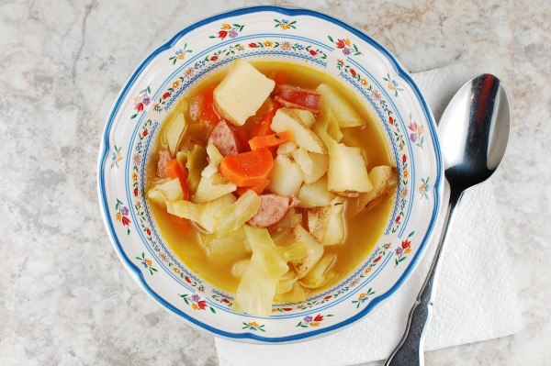
Serves: 8-10 servings

Ingredients
- 1 medium onion, chopped
- 2 garlic cloves, crushed
- 6 medium potatoes, scrubbed and chopped
- 4 carrots, chopped
- ½ head of cabbage, chopped
- 1 smoked sausage, sliced
- 2 32oz boxes chicken broth
- 2 bay leaves
- 1 tsp. thyme
- Salt and pepper to taste
- ⅛ tsp. sugar
- 1 Tbs. cider vinegar, optional
Instructions
- Cook the onion and garlic in a bit of oil until the onion is soft.
- Add remaining ingredients, except cider vinegar, to the pot.
- Bring to a boil and cook until potatoes are tender, about 30 minutes.
- Stir in cider vinegar, if desired.
- To make soup in slow cooker, place all ingredients in crock and cook on high 5-6 hours or low 7-8 hours. No need to cook onion and garlic before adding to slow cooker.
- Add the cider vinegar to the pot at the end of cooking. A few of us stirred a couple of drops into our bowls of soup. I liked the soup both with and without the vinegar.

